Salaried GP – 4-6 Sessions per Week
Split over Wednesday, Thursday and full day Friday
Closing date 30th June 2026

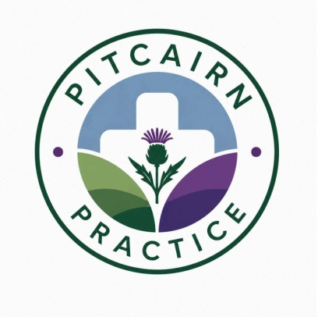

We are seeking a friendly, enthusiastic, and dynamic GP to join our innovative, forward-thinking practice.
We are a well-established GMS training practice with an excellent reputation (list size approx. 5,600), operating across two sites in the semi-rural villages of Balmullo and Leuchars. Our locations are ideally situated between the historic town of Cupar, the beautiful coastal town of St Andrews, and the vibrant city of Dundee.
We pride ourselves on being a collaborative and supportive practice, led by 3 GP partners and supported by a skilled, dedicated multidisciplinary team including ANPs, practice nurses, practice pharmacists, a mental health nurse, healthcare assistants, and an experienced administrative team. We are committed to putting our patients first while also fostering a positive and supportive working environment for our staff.
As a teaching and training practice, we work closely with ScotGEM and the Universities of St Andrews, Dundee, and Aberdeen. We host GP registrars and medical students, and we are passionate about education and ongoing professional development. We also embrace innovation and utilise IT solutions, including electronic asynchronous consulting, to enhance efficiency and patient care.
We are looking for a GP who:
- Enjoys working as part of a close-knit, supportive team
- Is proactive, motivated, and happy to roll up their sleeves
- Has an interest in innovation and service improvement
- Shares our commitment to delivering high-quality care to our patient population
This is an excellent opportunity to join an enthusiastic and forward-looking practice, committed to continually improving what we offer and striving to deliver outstanding care for our community.
For further information or to apply, contact Jodie Dobryden at jodie.dobryden@nhs.scot. Applications by CV and supporting letter please.

